Locomotion Exhibited by Protozoans
The types of locomotion are: 1. Amoeboid Movement 2. Flagellar Movement 3. Ciliary Movement.

Protozoans: Type of Locomotion #:1. Amoeboid Movement
In Amoeba, movement of the animal is made by the throwing of pseudopodium (Fig. 10.60), called amoeboid movement. This is the most primitive kind of movement which is caused by contractility and is also the characteristic of Sarcodina and many Sporozoa. In the direction of movement of Amoeba a new pseudopodium is formed and the pseudopodium at the opposite side gradually disappears.
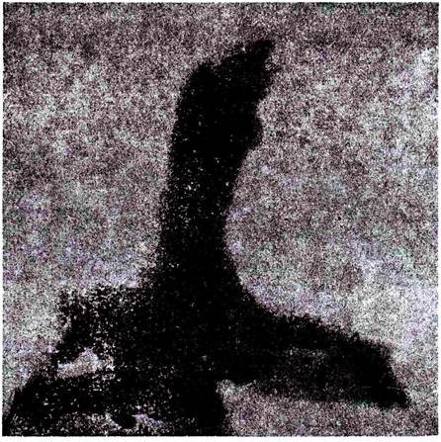
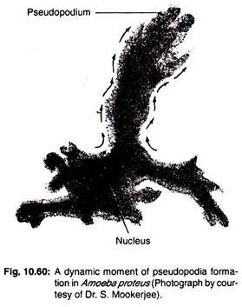

Locomotor Organelles:
Excepting a few Suctorians which are sessile in adult stage most protozoa possess definite locomotor organelles which are closely associated with the body surface.
These organelles are:
Pseudopodia:
A pseudopodium may be defined as a temporary projection of a part of cytoplasm, mainly formed from the ectoplasm. These are characteristic organelles of Sarcodina, certain Sporozoa and many Mastigophora where the pellicle is ill defined. They act as locomotory and feeding organs.
Types of pseudopodia:
According to form, structure and activity four different kinds of pseudopodia are recognised (Fig. 10.59).
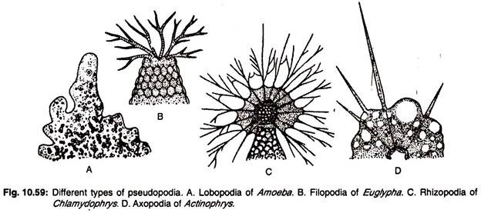
These are:
(a) Lobopodium
(b) Filopodium
(c) Reticulopodium or Rhizopodium
(d) Axopodium or Actinopodium
(a) Lobopodium [Gk. lobes = lobe; podium = foot]:
It is a short, finger or tongue-like projection which is accompanied by a flow of endoplasm and ectoplasm. The pseudopodium is broad with rounded or blunt tips. The ectoplasmmic area is distinctly clear, called the hyaline cap. It is the characteristic of many amoebas such as Amoeba, Chaos, Entamoeba, Arcella, Difflugia.
(b) Filopodium [L.filo = a thread; podium = foot]:
The filopodium is a slender, thread-like or filamentous projection. It is formed by the ectoplasm alone and without a hyaline cap. The filaments are narrow and may be branched but do not anastomose, Filopodium is the characteristic in Filosea (e.g., Gromia, Euglypha etc.).
(c) Reticulopodium or Rhizopodium [L. reticulos = a net, podium = foot]:
Similar in structure to that of filopodium but the branches anastomose. The numerous branched and anastomosed pseudopodia form a dense network, help primarily in capturing the prey and the secondary function is locomotion. It is found in Elphidium.
(d) Axopodium or Actinopodium [Gk. axo = an axle; podium = foot; aktis = ray]:
It is a semi-permanent structure and is made up of an axial rod enveloped by cytoplasm. The axial rod is made up of a number of fibrils and arises either from the central part of the body or from the nucleus or nuclei in multinucleate forms or from an intermediate zone between ectoplasm and endoplasm. Axopodia are found in Actinophrys, Actinosphaerium, etc.
The physiological manifestations in pseudopodia formation are explained with the help of the following theories:
(i) Sol-gel theory or Change of viscosity theory:
This theory was proposed by Hyman (1917) and strongly supported by Pantin (1923-26), Mast (1925-31) and others.
According to this theory the body of the Amoeba is made up of 4-regions:
(a) The outer most thin and elastic cell membrane or plasma membrane,
(b) Plasmagel, an outer stiffer jelly-like region of the ectoplasm,
(c) The plasmasol, an inner more fluid region of the endoplasm and
(d) A hyalin fluid which is a clear ectoplasmic area between plasma membrane and plasmagel.
This theory assumes that the pseudopodium is formed by the change of sol to gel and gel to sol states in the peripheral cytoplasm. The tip of the pseudopodium controls the change.
During the formation of the pseudopodium the plasma membrane of Amoeba gets attached to the substratum by means of an adhesive secretion. A local reversion of plasmagel to plasmasol takes place at the anterior end by internal chemical reaction.
The gel at the anterior end becomes thinner and weak. The rest of the plasmagel exerts pressure on the weakened area. The contracting plasmagel of the posterior end is continuously changed into plasmasol and it flows forwards and breaks the weak gel.
Anteriorly the plasmagel tube is continuously regenerated by gelation of plasmasol and a new pseudopodium is formed. The animal then progresses forward with the help of the pseudopodium (Fig. 10.61).
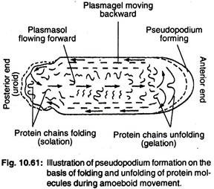
Remark:
Though the theory is most popular to the zoologists but the actual mechanism of reversion of gel to sol or vice versa could not be explained properly.
Molecular mechanism:
The amoeboid movement is related to the sol-gel transition of cytoplasm and various non-muscle contractile proteins, Ca⁺⁺ ions and membrane receptors are involved in this.
Under normal or resting condition the ectoplasm remains in gel state in which the actin filaments are cross-linked with one another to form a complex network-like structure and sol-state condition of the endoplasm contains non cross-linked actin filaments.

Protozoans: Type of Locomotion # 2. Flagellar Movement:
Flagellar movement is performed by flagella and it is more advanced type than the amoeboid type.

Definition:
“Flagella are extremely fine, thread-like or whip-like, highly vibratile, centriole based locomotor organelles”.
In general the flagella are long and their motion is whip-like undulations.
Occurrence:
They occur in all mastigophorans and also in flagellated stages of some Sarcodina and Sporozoa.
Structural aspect:
Pitelka (1949, 1962) observed the following structures of the flagella of euglenoid organisms under light and electron microscopes.

Structure under Light Microscope:
The flagella are slender, filamentous extensions of the cytoplasm and are highly vibratile. The length of the flagellar state is about 150 µm. They consist of an inner elastic central axis called axoneme and an outer protective contractile cytoplasmic sheath.
The sheath is made up of fibrillar substances which is a semifluid matrix and the fibrils of the sheath frayed out laterally along the length of the flagella and these lateral hair-like projections of the flagellum are called mastigonemes or flimmer. The term mastigoneme was given by Deflandre (1934). The outer sheath is circular or more or less flattened in cross section.
According to the disposition of the mastigonemes the flagella are classified into following types (Fig. 10.63).
1. Anematic:
Flagella are without mastigonemes, e.g., Noctiluca.
2. Stichonematic:
Flagella with a single row of mastigonemes on one side of the flagellum (Fig. 10.63A), e.g., Euglena.
3. Pantonematic:
Flagella with two or more rows of mastigonemes on the sides (Fig. 10.63B), e.g., Peranema, Monas socialis.
Remark:
Pitelka (1949) reported that no frayed mastigonemes in the flagellum of Peranema.
4. Acronematic:
Flagellum does not bear any arrangement of mastigonemes but a terminal filament is seen (Fig. 10.63D), e.g., Polytoma, Chlamydomonas.
5. Pentacronematic:
When the flagellum bears two rows of mastigonemes on the sides and the flagellum ends in a terminal filament without mastigonemes (Fig. 10.63C), e.g., Urcoclus.
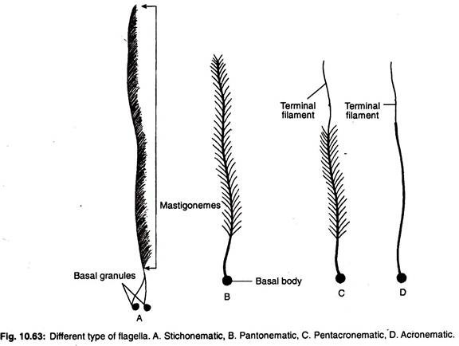

Origin of the Flagellum:
A flagellum originates from a basal body or basal granule or sometimes called a kinetosome or blepharoplast or kinetonucleus which is compact and spherical in shape, and situated in the ectoplasm. The basal bodies are modified centrioles, contain DNA and have the power of self-replication.

Structure under Electron Microscope (Fig. 10.64):
(A) Ultrastructure of the axoneme:
The axoneme is composed of a bundle of microtubules (sometimes called fibrils) which extend from the base to the tip of the flagellum. The fibrils constitute a ring like doublet peripheral microtubules which are situated around two central singlet microtubules (9/9+2).
In Trypanosome lewisi, the axoneme is composed of 8 fibrils. All the microtubules are protected by a protoplasmic sheath which is continuous with the plasma membrane or cell membrane.
The two central microtubules are protected by a central sheath and these microtubules remain separated each other and form the central shaft of the flagellum. The diameter of the axoneme is variable in different species. The peripheral doublet microtubules are separated from each other by 200 Å.
The central microtubules are circular in cross section and are about 200 Å in diameter. The peripheral doublets are ellipsoidal in cross section and each of the doublets is composed of two microtubules and are called A microtubule and B microtubule or A tubule and B tubule or sometimes, called sub-fibres.
A tubule (microtubule) is smaller, complete and remains at the inner side, but B tubule is larger, incomplete and remains at the outer side (Fig. 10.64B).
All the microtubules of the axoneme are composed of globular protein called tubulin. The tubulin is a dimer varying from 11 kilodaltons to 12 kilodaltons. Each dimer is formed of two monomers, namely α and β monomers or α is represented by A tubulin and β monomer is represented by B tubulin. The A tubule and B tubule are microtubules.
The inner A tubule of each peripheral doublet is composed of 13 proto-filaments and outer B tubule contains 10 to 11. These proto-filaments are the subunits of tubulin protein. A pair of arms called dynein arms which project from A tubule, arranged in a clockwise direction towards B tubule of the neighbouring doublet (Fig. 10.64B).
The dynein arms are called because the arms contain the dynein protein, similar to metazoan muscle myosin. The molecular weight of dynein is 5 x 10⁵. The outer dynein arms are spaced at regular interval of 24 nm. The protein dynein contains a high molecular weight protein—ATPase, required Mg⁺⁺ and Ca⁺⁺ for its activity and is able to cleave ATP releasing chemical energy.
The central two microtubules are called namely C₁ and C₂ and may or may not be present. Nine delicate spokes extend from A tubule of each peripheral doublets and project towards the central sheath. These spokes are radially arranged and terminate into a head which may have a forked structure.
The adjacent two peripheral doublets are connected by an inter-doublet bridge, called nexin link, made up of an elastic protein nexin. The nexin links may act as stimulators which maintain the geometrical shape of the axoneme during the sliding motion.
(B) Ultrastructure of basal bodies:
The structure of basal bodies is comparable to the structure of the centriole. A cross section of the basal bodies (Fig. 10.64C) shows a ring of nine peripheral triplets. Each triplet is composed of 3 tubules, namely A, B and C. Tubule A appears circular in cross section while tubules B and C are crescent-shaped in outline. The tubules are microtubules.
A central cylinder-like structure without any singlet is called the hub. A and B tubules are elongated to form the doublet of the flagellum. From the hub nine radially arranged spokes originate which are connected to the peripheral triplets. The dynein arms are absent in triplets.
All the fibrils of the flagellum and cilia are anchored through the plate-like structure, called basal plate. The hair-like root-let fibres arise from the basal bodies which penetrate into the cytoplasm. The root-let fibres are contractile in nature and help to pull the flagellum or alter its orientation.
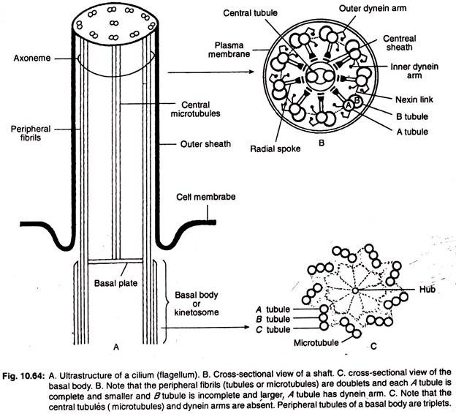
Modification of the structure:
The cytoplasmic sheath of Trypanosoma is cross striated. In Trichomonas and Trypanosoma a delicate membrane with vibratile nature which extends out from one side of the body, called undulating membrane and a flagellum always borders the outer margin of the membrane.
Number of flagella:
The number of flagella varies from species to species. The phytoflagellagtes usually have one or two flagella and zooflagellates bear one to many. Single flagellum is present in Trypanosoma, Leptomonas and Leishmania.
The two flagella are present in Cryptobia, and Ochromonas. Two to four flagella are present in Chilomastix and Retortamonas. Four to six flagella are seen in Trichomonas and Giardia, and numerous flagella are present in Trichonympha, a termite flagellate.
A mastigont system is a complex structure formed by groups of flagella and several microtubular and microfibrillar organelles is (e.g., Trichomonas, Trichonympha).
On the basis of attachment and direction of movement the flagella are of following types:
1. Tractellum:
The flagella are generally originated from the anterior part of the body and the flagellum which is directed forward is called leading flagellum and its movement helps to pull the organism forward. Another flagellum orginating from the anterior end is directed backward is called trailing flagellum. This flagellum helps to steer the course of movement or trails behind, e.g., Bodo (Fig. 10.65).
2. Pulsellum:
When the flagellum is situated at the posterior end of the body and is used to push the body forwards by its vibration (e.g., Trypanosoma).
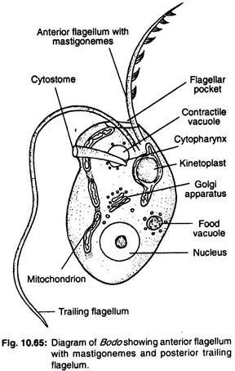

Process of Flagellar Locomotion:
The mechanism of flagellar locomotion (Fig. 10.67A-D) is not clearly known. As to the way in which a flagellum accomplishes locomotion there are four theories.
(a) Screw theory of Butschli:
It postulates a spiral turning of the flagellum like a screw resulting a propeller action which pulls the animal forward.
(b) Metzner’s theory:
Metzner has advocated that the flagellum beats in a circle tracing a cone and generates sufficient current to pull the animal forward.
(c) Theory of Ulehla and Krijsman:
According to this theory the ordinary movement of a flagellum is a sidewise lash consisting of an effective downward stroke followed by a relaxed recovery stroke by which the flagellum is brought forward again.
(d) Sliding tubule model:
This is the most widely accepted model. The sliding of the microtubules involves the movement of the flagellum. According to this theory, the peripheral microtubules form a linkage with each other and maintain a constant length.
The adjacent doublets slide past each other causing the entire flagellum to bend. The dynein arms of the doublets provide the sliding force and sliding involves the establishment of the cross-linkages (Fig. 10.66).
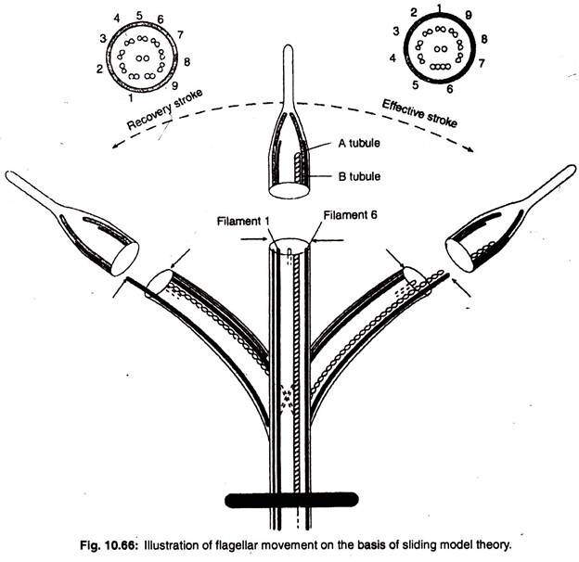
Remarks:
There is no doubt that flagellar waves pass from base to tip increasing in amplitude and velocity demonstrating that flagellum is an active unit that generates its own energy.
The flagellar movement has already described under the term “Locomotion in Euglena”.

Protozoans: Type of Locomotion # 3. Ciliary Movement:
Ciliary movement is exhibited by the beating of the cilia. It is the most advanced, complicated and co-ordinated mode of locomotion.

Definition:
“Cilia are fine, short, hair-like, centriole-based protoplasmic processes, characteristic of many protozoan and metazoan cells”.

Occurrence:
They are characteristic in Ciliata and larval Suctoria.

Structure of Cilia:
The cilia and flagella possess nearly the same structures except they differ in some points:
(i) Cilia are relatively shorter in length than the flagella.
(ii) Comparatively cilia are more numerous in number than the flagella. The cilia occur in patches or tracts but flagella generally occur singly or in pairs.
(iii) Absence of mastigonemes in cilia but present in flagella.
(iv) The microtubules of the axoneme extend from the base to the tip in flagellum but in cilium the microtubules are reduced in number towards the tip.
(v) Presence of kinetodesma in cilia but absent in flagella.
(vi) The movement of the flagella and cilia exhibit certain differences. Flagella exhibit undulating motion and beat independently but cilia in the longitudinal rows beat perpendicularly one after another (metachronous) and those in the transverse rows beat synchronously.
A. Under light microscope:
The cilia are fine, short, stiff, oar-like protoplasmic processes and emerge from the ectoplasm. The length of the cilia varies 10 µ to 15 µ. The cilia may be found all over the body (e.g., Paramoecium) or may be restricted to certain parts of the body (e.g., Vorticella).
Ciliary arrangement:
The cilia are arranged in longitudinal, oblique or spiral rows, develop from either ridges or furrows. The ciliature can be divided into body or somatic ciliature (when the cilia occur over the body surface) and the oral ciliature which is confined to the mouth region.
The length of the cilia is uniform in Protociliates but in many ciliates the length is larger in certain parts of the body. A small row of close set cilia are found in some cases, called Pectinella.
Each cilium arises from a basal body or kinetosome which lies in the ectoplasm and consists of two parts:
(i) A basal body or kinetosome or kinetochore lies below to the cell membrane and
(ii) A shaft—short, threadlike structure lies above the pellicle.
The shaft varies 5-10 µm in length and 0.27 µm in breadth. In flagellum the shaft is about 150 µm in length.
B. Ultrastructure of cilium (Fig. 10.64):
The ultrastructure of a cilium is given by Satir (1968). The shaft of a cilium is composed of 9 fibrils or 9 paired microtubules, with central pair of single tubules, called the axoneme surrounded by a membrane which is continuous with the pellicle. A fine striated fibril called kinetodesma (PI. kinetodesmata) that connects each kinetosome or basal body and extends in the direction of an adjacent cilium of the same row.
The cilia, kinetosomes and kinetodesma together make up a kinety. The number of fibrils may exceed 500 in each kinetodesma. These fibrils are striated and form the framework of the cilium.
The axoneme is composed of a ring-like 9 doublet peripheral microtubules situated around two central singlet microtubules (9/9 + 2). The peripheral groups of microtubules or fibrils are radially arranged and are interspaced at 40° intervals. Each peripheral group consists of two microtubules which form a doublet. The two microtubules are called A microtubule or tubule and B microtubule or tubule.
The average diameter of microtubules vary from 180-250 Å. All the microtubules of the axoneme are composed of a globular protein, called tubulin.
A tubule (microtubule) of the peripheral group is smaller, complete and consists of 13 proto-filaments and B tubule is larger, incomplete and contains 10-11 proto-filaments or called tubulin subunits. The central two microtubules are unpaired separated each other and called C₁ and C₂ respectively.
The peripheral fibrils are ellipsoidal in cross section and central unpaired microtubules are circular in cross section. The tubulin protein is a dimer varying from 11,000 to 12,000 daltons. From the A microtubule of the doublets projects two processes called dynein arms.
The dynein are composed of a dynein protein. The dynein is an enzyme which degrades ATP to the ADP. The mol. wt. of dynein is 5 x 10⁵. The microtubules are hollow and cylindrical in shape and peripheral group is composed of α and β tubulins.
The peripheral doublets are connected by nexin links which are composed of a protein called nexin. The molecular weight of the nexin is about 15 x 10⁴. The function of the nexin link is unknown but they may serve as stimulators that maintain the geometric shape of the axoneme during the sliding motion.
Nine delicate spokes extend from A subfibril of each peripheral doublet towards the central sheath. These spokes are radially arranged and terminate into a forked structure, called radial spokes.
The ultrastructure of the basal body of the cilium is like that of an basal body of flagellum. In cross section the basal bodies consist of 9 peripheral triplet tubules. Each triplet consists of 3 tubules or microtubules. These tubules are named A tubule, B tubule and C tubule.

Ciliary Movement:
All free-swimming ciliates swim in a spiral path. During swimming an individual cilium bends throughout its length and strikes the water (Fig. 10.67 E-F). As a result the organism moves in a direction opposite to that of the effective beat and the dispelled water moves in the direction of the beat. The cilia in the longitudinal row move metachronously (wave-like action) and those in the transverse row act synchronously.
The ciliary movement has already been described under the term ‘Locomotion in Paramoecium’

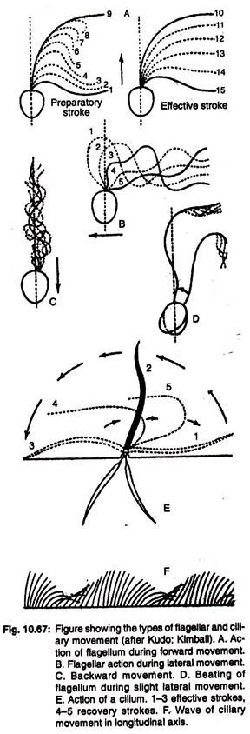

Views for Metachronous Rhythm:
There are two views regarding the controlling mechanisms of metachronous rhythm of cilia in Paramoecium.
1. Taylor’s neuroid fibre theory (1964):
He proposed that metachronous rhythmic movements of cilia are controlled by infra ciliary system which co-ordinates the beating of cilia.
Remarks:
Naitoh and Eckert (1969) have stated that the role of infra ciliary system has not been conclusively demonstrated.
2. Eckert’s electropotential theory (1972):
He has proposed that the potential differences are created by polarization and depolorization during an effective and a recovery stroke of each cilium which are responsible to maintain the metachronic rhythm.

